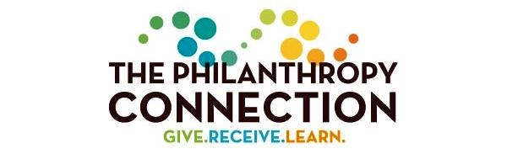
New Member Packet

Table of Contents
Welcome 2
Events and MEMBERSHIP Engagement Opportunities 3
Volunteer Committees 4
Grants Review Teams + Grant-making Process 5
Young Philanthropist Initiative: A Model Program 7
Frequently Asked Questions and Answers 7

Welcome
It is a pleasure to welcome you to The Philanthropy Connection (TPC), a thriving Boston-area women’s collective giving organization committed to encouraging and educating philanthropists across generations.

As a member of TPC, we want you to be involved in a way that meets your needs and goals. We offer avenues to get engaged with Greater Boston’s non-profit community, to use your talents to serve others, and to be a member of a committed group of multi-generational philanthropists making profound changes in our communities. Some members join TPC for the confidence of knowing that their membership contribution supports thoroughly vetted non-profits; others opt to participate by helping to choose which non-profits we support; and some help run TPC by participating on one or more of a variety of committees. Whatever your preference, the choice is yours.
Thank you so much for joining our community. We look forward to sharing many opportunities to Give, Receive, and Learn together.
With our thanks,

Sandy Lawrence, Chair, Member Engagement Committee
sandrablawrence@gmail.com
Susan Benford, President and Chair, Development Committee
Benford@ThePhilanthropyConnection.org

Events and Member Engagement Opportunities
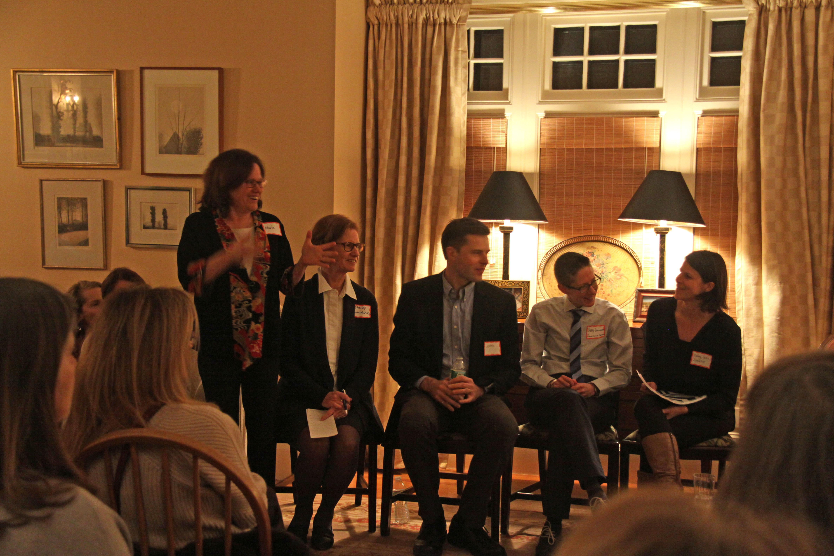
Below is a list of past events, typical of TPC. For a look at what’s in the queue for the future, please visit The Philanthropy Connection Events page.

Philanthropy Dialogues (members only education events)
“Philanthropy Dialogues” are periodic educational events for members that are focused on topics related to philanthropy. Past Dialogue topics include barriers and contributors to school success, challenges in Massachusetts’ foster care system, and the importance of STEM education for young women. Led by current or past TPC grantees and often held in a member’s home, these intimate gatherings are excellent opportunities to learn more about what TPC is and does, to meet TPC members, and to better understand pressing challenges in Boston’s philanthropic landscape.

Connect The Dots (Education for Members and potential new members)
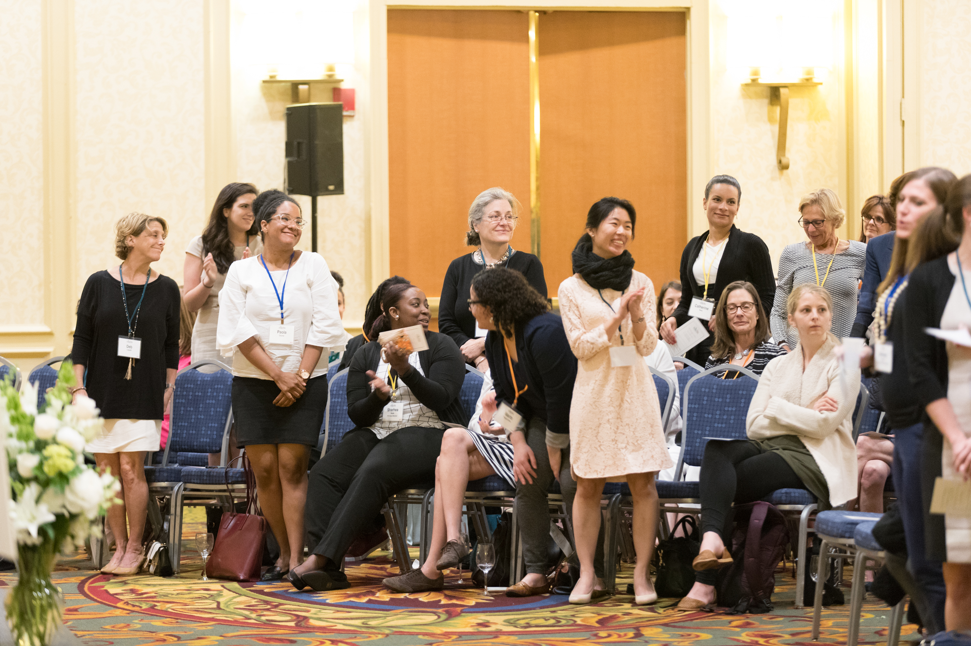
“Connect the Dots” events offer additional opportunities to meet TPC’s grantee organizations and members, and to introduce new women to the organization and its mission. Oriented primarily for prospective and new members, these gatherings take place in a member’s home or an interesting venue, inviting conversation about TPC, its grantees, and its mission.

Grantee Wish Lists
Are you ready to dive in and help one of TPC’s grantee organizations directly? We thought so! We ask Grantees to let us know what kind of help they need most. Many of our members opt to get involved personally in these wonderful organizations that are having such an important impact on our community. Go to our website and click on the grantee photos on the home page photo slider to view each grantee’s profile and wish list.

Grants award and all member meeting
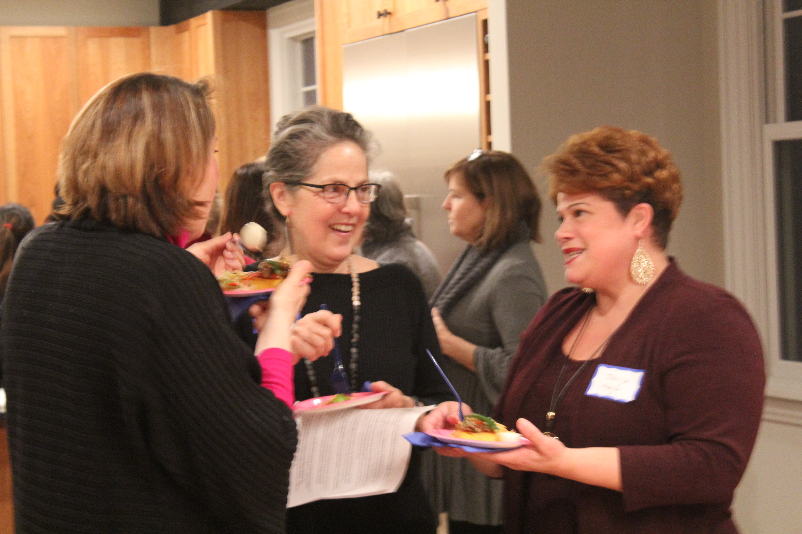
Welcome to TPC’s Academy Awards, sans gowns and stilettos. Held in late May or early June, this is the night during which TPC announces its new class of grantees. This is a terrific opportunity for members to come together, celebrate our work, and meet TPC’s non-profit and community partners. You seriously don’t want to miss this inspiring event!

Volunteer Committees
TPC is a volunteer organization run by its members and a part-time administrator. Below are descriptions of our Committees and ways to get involved.

Member Engagement Committee
Chair: Sandy Lawrence

Committee Goals: The Member Engagement Committee (MEC) is responsible for new member recruitment and the membership experience, and works closely with the Young Philanthropist Initiative. The MEC organizes Connect the Dots events and Philanthropy Dialogues, and runs the Grants Award and Member Meeting held in late May or early June. The MEC is always looking for new, exciting ways to connect current and potential members to TPC.

Where we need your help: The MEC needs volunteers to host and support our educational and recruitment events such as Dialogues and Connect the Dots gatherings, and is always looking for members to help think of creative ways to get new members and keep members involved. We need members to introduce friends, family, and colleagues to TPC.

For further information: Contact Sandy (Sandrablawrence@gmail.com)

Grants Committee
Co-Chairs: Barbara Gaskin and TBD

Committee Goals: The Grants Committee oversees the grant-making process. This committee’s responsibilities include developing the annual grants calendar; recruiting and managing Grant Review Teams; and managing the Liaison Program (through which a pair of members serves as the conduit between TPC and each of our grantees).

Where we need your help: Our grants work is by nature cyclical and takes place over a six-month period beginning each fall. To kick off the process, there is a one-month sign-up period starting in October for those interested in participating on a Grant Review Team. We are looking for members to serve in leadership roles as Team Captains, Deputies, and Finance Leads, as well as women to work on grant teams.

Note: if you are interested in being a Captain, Deputy, or Finance Lead, please email Barbara. Signup for being a grant team member occurs in October, so there’s no need to let us know now of your interest.

For further information: Contact Barbara (bgaskin@thephilanthropyconnection.org)

Marketing and Communications Committee
Chair: Cheryl Wakeham

Committee Goals: The Marketing and Communications (M&C) Committee plans, implements, and manages communications between TPC and all stakeholders (e.g., members and donors, prospective members, the non-profit community, the press). These efforts include the Link, a monthly publication filled with grantee and member news, a social media presence, our PR and media placement, and the maintenance of TPC’s signature “look.” This committee additionally oversees the website and member portal.

Where we need your help: We need volunteers to help with social media, website maintenance, PR, writing articles, and conducting interviews for the Link, as well as pro bono design and web design efforts.

For further information: Contact Cheryl (cwakeham@thephilanthropyconnection.org)

Development Committee
Chair: Susan Benford

Committee Goals: The goal of this committee is to close the funding gap between the actual cost of operating TPC (think Dialogues, our part-time administrator, bookkeeper and accountant, funding our Fellows, the Grants Award meeting, Connect the Dots gatherings, etc.) and members’ contributions toward these expenses ($50 for Young Philanthropists and $100 for other members). The sources of these funds are members and sponsors, and may extend to foundation support in the future.

Where we need your help: We are always looking for creative women who might be able to introduce us to new funders, for those able to help with writing a grant, and for those who believe in TPC’s mission and want to ensure the organization’s stability.

For further information: Contact Susan (benford@thephilanthropyconnection.org)

Young Philanthropist Initiative
Chair: Marta Pagan-Ortiz & Jesse Hatfield

Committee Goals: The Young Philanthropist Initiative (YPI) is responsible for increasing, diversifying, and retaining members 35 years old and younger, working closely with the Member Engagement Committee. It runs one or two Connect the Dots gatherings; recruits, selects, interviews, and onboards Fellows, and ensures that they meet TPC Fellowship requirements; and develops and manages new programs to increase retention of YPs and Fellows, while building community among YPs, Fellows, and all other TPC members.

Where we need your help: For the Fellows program, we would appreciate recommendations for candidates, and help with screening applications and interviewing finalists. Additionally, we welcome your ideas and planning talent for events that will foster community and member retention in members 35 years of age and under. And we are also interested in your suggestions for new members!

For further information: Contact Marta (marta.pagan@gmail.com)

Other TPC committees include:
- Governance Committee: open to Board members only, per our bylaws;
- Finance Committee: Chaired by the Treasurer, Martha Bedell, this committee has up to two additional members. For further information, contact Martha (martha@marthabedell.com).

Grants Review Teams + Grant-Making Process
Who does TPC fund? TPC funds organizations addressing at least one of the following: poverty and/or income inequality; employment and/or educational opportunity and readiness; health and wellness; social bias. TPC funds organizations located in the Greater Boston area defined largely as towns falling within the I-495 loop, plus: Amesbury, Haverhill, Methuen, Lawrence, Lowell, Maynard, Hudson, Marlborough, Milford, Franklin and towns north of the intersection of I-495 and Rt. 25. It also funds national organizations with a local chapter that has its own 501(c) status. All applicants must have annual revenue of $200,000 up to $2,000,000. We are committed to funding diverse organizations whose leadership reflects the populations served by the non-profit.
What does it mean to join a Grant Review Team? You will read grant proposals from non-profit organizations that serve low-resource individuals and families living in the Greater Boston area. You will learn about the innovative ways that these organizations are working to mitigate income, employment, education, health, gender, and racial disparities. You will work with and get to know the small group of TPC members on your team – some of the most generous, thoughtful women in Boston. You will play a key role in determining those organizations that will be awarded TPC grants. You will make a difference. You will change lives.
Composition of a Grant Review Team: Each Grant Review Team, which has roughly eight members, includes a Captain (or two Co-Captains), Deputy Captain, and Finance Lead. Team sign-up occurs in October-November of each calendar year. Grant Review Team participants must have renewed their memberships for the granting year.
Member responsibilities include: attending two or three Team meetings between December and April; evaluating the preliminary (or letter of intent) applications and participating in Team discussion and decision-making about advancing applicants to the full proposal stage (meeting 1); evaluating full proposals and participating in Team discussion about whether to request a site visit (meeting 2); determining which applicants will be recommended for the ballot (meeting 3, which may be done in person, conference call or via e-mail); going on site visits when possible; and helping write a narrative about each non-profit that will be presented on TPC’s ballot.
In May, all active members are invited to vote for which grantees will receive funding. Members are strongly encouraged to attend the Grant Awards and All Member meeting celebration in May/June to meet and welcome our new class of grantees. It is an ideal occasion to share what TPC is and does, so please bring prospective members.
In addition to vital funding, what else does TPC provide? The answer is YOU! To complement its funding, TPC also provides grantees with the opportunity to leverage skills of TPC members. For each grantee, TPC provides two Liaisons who act as the conduit between the non-profit and TPC. The grantee gets the opportunity to meet regularly with TPC members, tell its story, and post its immediate needs, or “Wish List”, on our member portal.
In return, Liaisons and other members get the chance to communicate directly with like-minded partners who are actively addressing needs and providing services to our local communities. We have numerous stories about TPC members who have become Board Members or have assumed long-term volunteer roles with our grantees. We’d love to help connect you with one of our exceptional grantees!
Who are our grantees? Since its inception in 2012, TPC has provided more than $1 million to 43 organizations within Greater Boston. View a list of our current and alumni grantees. TPC is able to fund these organizations because of your support and participation. Thank you!

Young Philanthropist Initiative: A Model Program
At The Philanthropy Connection, we are deeply committed to fostering the next generation of philanthropists. We welcome and encourage women between the ages of 18 and 35 to join us as Young Philanthropists. Because our membership donation of $1,125 may be out of reach for those still in school or just beginning their careers, Young Philanthropists are offered an annual membership rate of $575, with the option of monthly payments. TPC offers programming and events specifically for Young Philanthropists, who are also invited to all TPC events.
Additionally, TPC provides Young Philanthropist Fellowships for women interested in becoming part of the women’s collective giving movement, and motivated to help TPC redefine what it means to be a philanthropist: anyone who donates her time, talents, and/or money in an effort to improve the lives of others. Fellows must be between 18 and 35 years old, be motivated to learn about philanthropy and the non‐profit landscape in Massachusetts, and live in the Greater Boston area.
Please visit our website to learn more about the Young Philanthropist Initiative: http://www.thephilanthropyconnection.org/young-philanthropists

Frequently Asked Questions and Answers
- What is my role as a member of TPC?
Our model of collective giving allows all levels of participation. Some members simply make their membership donation and vote for that year’s ballot finalists, knowing that each organization has been thoroughly vetted. Others become more involved through volunteering on a committee, attending education events, and/or building lasting relationships with our grantees by working with them during Volunteer Days. The choice is up to each member.
However, we hope that all members will invite prospective members to our many education events so that we can continue our good works supporting non-profits in the greater Boston area.
- I am not able to volunteer on a TPC committee or a grant team. How else can I offer my support?
Let us count the ways! Here are some ideas:
- Join iGive.com, which will donate between 0.8% and 4.0% of your purchases made at nearly 1700 businesses (place we bet you, too, shop!). After you join, your online shopping experience looks and feels the same. Sign up for iGive now!

- Help TPC on a night! Be a hostess or volunteer at a Connect the Dots gathering, a Philanthropy Dialogue, or any other event that interests you. To host or co-host an event, email Sandy Lawrence, Chair, Member Engagement Committee. (Sandrablawrence@gmail.com). To volunteer for an event, contact Ruth Isaacs, our Volunteer Coordinator (ruth@firstjobhelp.com).

- Fund a Fellow. Each year, young women 35 years of age and under compete for TPC Fellowships, which are sponsored by members. As they learn about what being a philanthropist means, the Fellows participate actively in running TPC. Support the next generation of philanthropists!

- Like TPC? Let your friends know! Better yet, invite them as guests to a Connect the Dots gathering or our Grants Award meeting in May/June.

- Support TPC’s education programs and administration: The $50 or $100 donation (depending on a member’s age) to defray TPC expenses covers only 40% of the actual costs of our Dialogues, Connect the Dots gathering, Grants Award meeting, Fellows funding, administrative support, and the nuts and bolts of operational expenses like accounting services. Help us run our organization without increasing these donations – contribute here.

- What is the term of my membership?
Membership is open year-round, and extends to Dec. 31 of the year after you join (i.e., if you joined on Feb. 1, 2018, your membership lasts until Dec. 31, 2019).

- I have a friend who wants to join TPC. What should I tell her to do?
Wonderful! She should visit our website at www.thephilanthropyconnection.org, click the “Join or Renew Now” button, and follow the instructions from there. Additionally, please invite her to an upcoming TPC event, listed on our website in the “Events” tab.

- What’s the best way to stay informed about TPC events?
We announce events via e-mail, social media, Facebook, and also post them to the Events section of our website. To avoid information getting lost in your spam folder, please add connect@thephilanthropyconnection.org and TPC14@wildapricot.org to your contact list! The e-mail address we use to communicate with you is the address you provided on your membership form. Please let us know of any change by e-mailing: connect@thephilanthropyconnection.org.
Be social with us on:
- Facebook: https://www.facebook.com/thephilanthropyconnection
- Twitter: https://twitter.com/philanconnect
- LinkedIn: https://www.linkedin.com/company/the-philanthropy-connection

- May I e-mail TPC’s membership in order to invite TPC members to a non-TPC related event?
No. We take privacy seriously and do not disclose our membership information to anyone outside of TPC. We ask that you do not provide our members’ information to anyone, including other non-profit organizations with whom you may be affiliated.

- How do I contact someone at TPC?
- Our part-time administrator, Alison, may be reached at connect@thephilanthropyconnection.org
- Or, you may leave a message at 617.544.7812
8. How can I contact other TPC members?
On our website, navigate to the tab, “Members Only”. Click on “TPC Member Directory” to email another TPC member. Email addresses are kept private.
Thank you for being a part of TPC – we look forward to getting to know you.

